Into to Google Photos app
Google photos can be used from an app downloaded to your device or from the Google Chrome Internet browser. This intro will cover Photos by using Chrome.
Launch Google Chrome . Then click or tap the 9 dot cube.
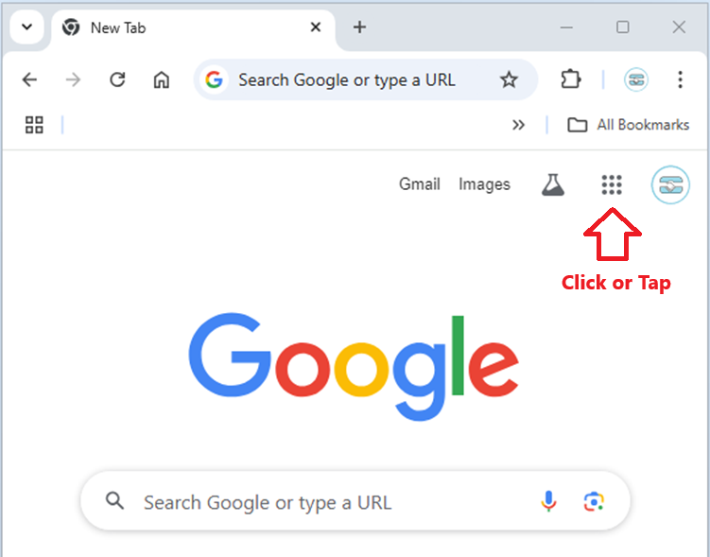

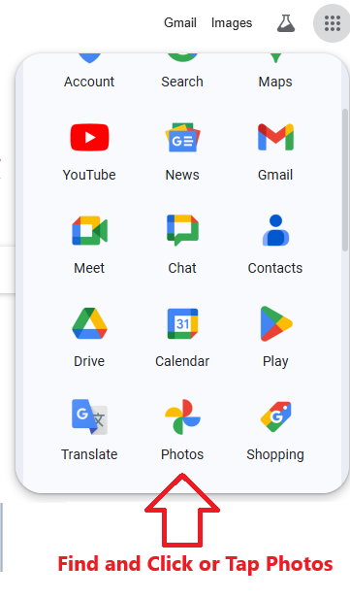
If your browser is not already signed into Google, then this appears
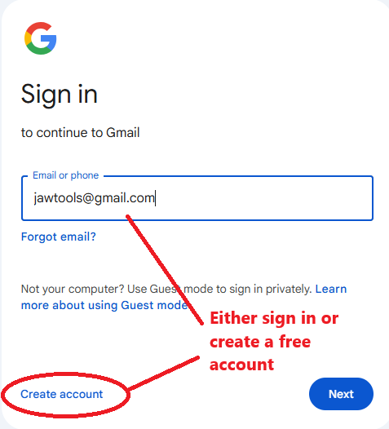

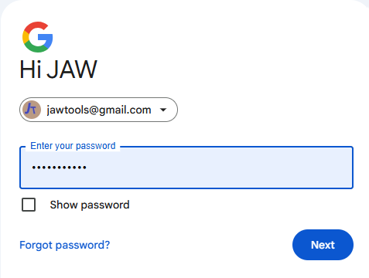

CLICK NEXT on both screens

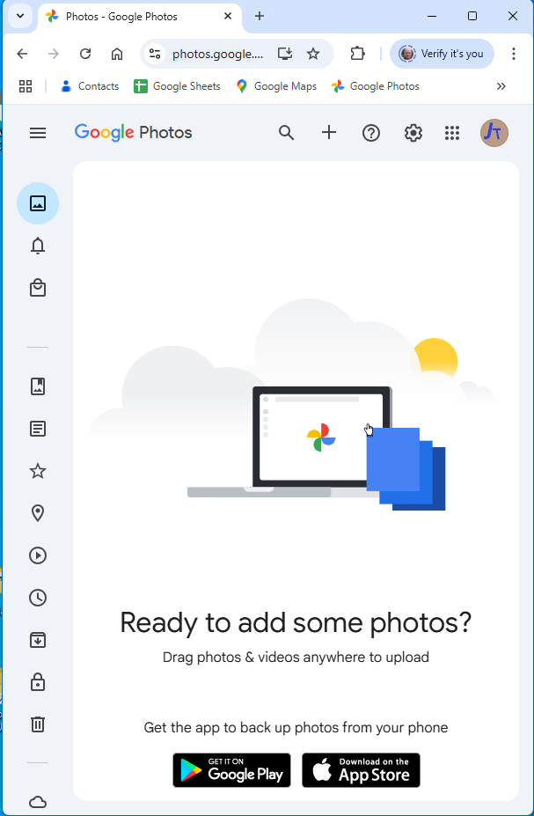

Drag and Drop
Open MS File explorer (in this example – on Apple use their file manager)
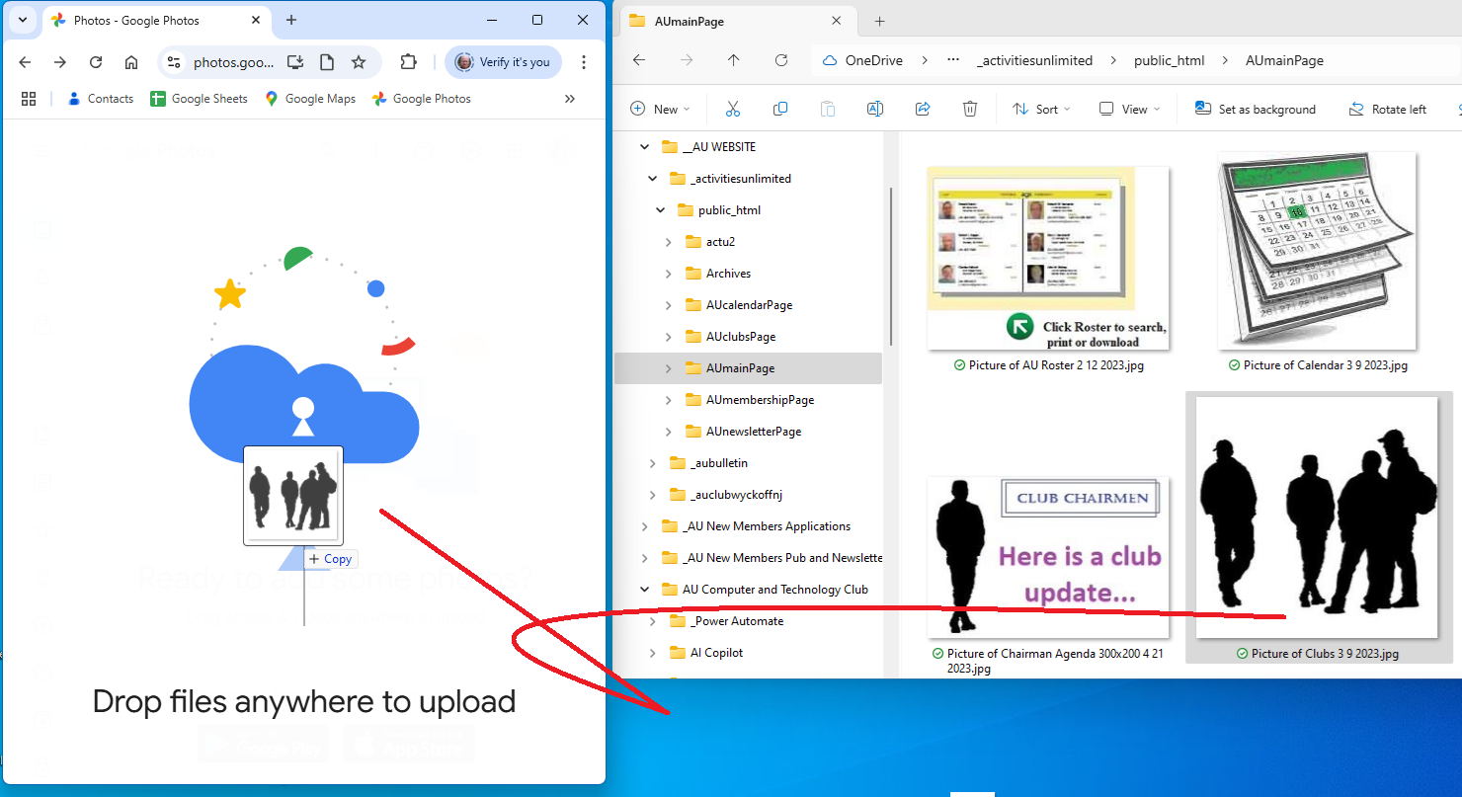
- Left click on the image
- Holding the left click drag to mouse pointer to the “drop files anywhere” window
- Release the mouse click

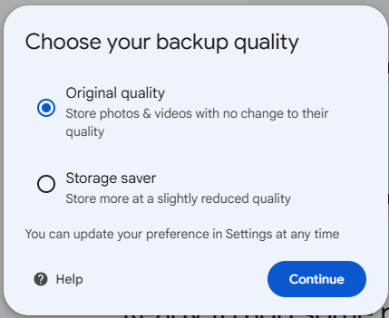

NOTE: in this exercise “Original quality” is checked when asked for

